**The Idea of this Project**

The idea was to combine my and Nina's prototypes to power her, and use it as visitor interaction. Then we changed the idea to be a different prototype, for the arch, the idea was to power it with sensors when the visitors approach. Somehow with miss-communication we decided to make a new prototype that was the waking park experience aka (the interactive pathway), and my Sensors/rgb were for the purpose of three RGB lights powering by sensors(switch), changing smoothly colors when detect someone . But we weren’t satisfied with the smooth transactions even though we worked on it a whole day. We decided to use Joy-it sbc button matrix then, which I coded at the beginning then Julies tried to fix some changes at home but at the end, it wasn't smooth enough (and It didn’t worked every time). That’s the main reason why mine prototype wasn’t exactly present at Tuesday but I still worked on it a lot.

So the problem that I was solving at first was the connection between Visitors and the project himself, at the same time the way of powering Nina's prototype, also for the arch, and in the end implementing it with the idea Julies. the whole research and finding the real problem thing (which is the Problem Guide exam ) took me more than three weeks because I needed to change a subject a couple of times, I bought a full Arduino kit for it and researched every component that suits the best for it and the code was written through the process but at the end when we couldn’t succeed with the smooth effect we tried to use AI that’s why there some non human written and strange names, it change the code, also I used Libraries. Overall the main function of this installation is the connection between a user walking in the park and the lights created by mine installment which are also included. It's the first step away from the pressure plate that we discussed to change that idea and also answer the questions as the cheapest the lowest energy used and others ( you can check my problem guide document) but this is the solution to many of the problems.

**Development Log for Interactive Light Installation**

Objective:

To create an interactive light installation for a park that responds to visitor movements, enhancing the user experience with dynamic lighting effects and sensors.

Initial Concept:

The initial idea was to integrate sensor-driven RGB lighting into an archway that reacts to visitors moving nearby. This would pair with Nina's prototype to provide a seamless interaction within the installation.

Week 1-2: Research/Experimentation and Initial Testing

Research:

Part of the links that I researched(many more couldn’t remember every source)

<https://www.patreon.com/PLACITECH/posts>

<https://www.instructables.com/How-To-Use-Touch-Sensors-With-Arduino/>

<https://forum.arduino.cc/t/low-power-proximity-sensor-battery-powered/134958>

<https://forum.arduino.cc/t/difference-between-pwm-pins-and-standard-pins/4550>

ChatGPT also.

Components Bought/Tested:

Arduino Uno Board - The primary microcontroller board used for programming and integrating various sensors and outputs.

Breadboard - A solderless platform used to prototype circuit connections and layouts quickly.

HC-SR04 Ultrasonic Sensor - Used for measuring distances by emitting ultrasonic waves and measuring the time it takes for the echo to return.

SG90 Servo Motor - A small and lightweight motor capable of precise rotational positioning.

RGB LED Module - Contains red, green, and blue LEDs that can be mixed to create a wide range of colors.

Piezo Buzzer - An electronic device that produces sound when voltage is applied, typically used for audible alerts or signals.

IR Remote Control and Receiver - Allows wireless control over components, typically used for remote operation of devices like robots or light switches.

Jumper Wires - Conductive wires used to connect components on the breadboard without soldering.

Resistors - Electrical components that limit or regulate the flow of electrical current in a circuit.

Push Buttons - Simple switches that close or open a circuit when pressed.

LEDs (Light Emitting Diodes) - Small, efficient light sources that emit light when current flows through them.

Joy-it SBC Button Matrix - A grid of buttons that can be programmed to perform different functions when pressed, useful for user input and control.

MFRC522 RFID Reader - A radio frequency identification (RFID) reader used to read data from RFID tags, typically used for secure access control or tracking systems.

Capacitive Touch Sensor - Detects touch or proximity by measuring changes in capacitance, used for touch-controlled interfaces.

Photocell (Light Sensor) - Detects light levels and adjusts outputs accordingly, often used in automatic lighting or in conditions where light detection is necessary.

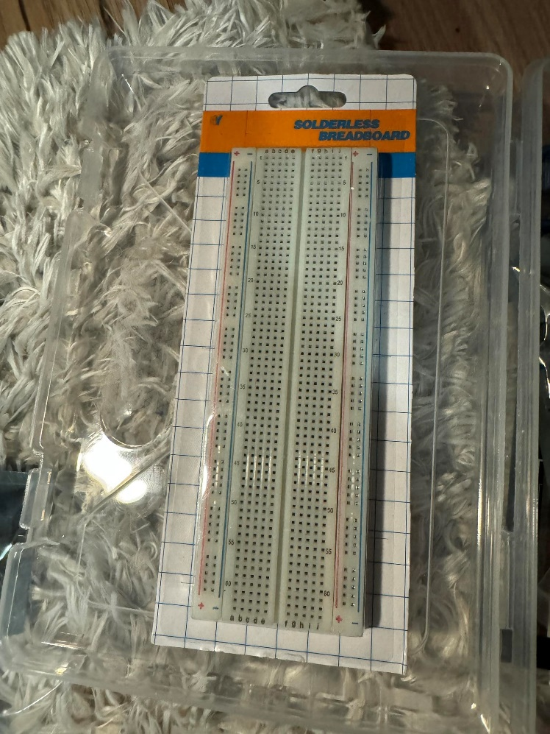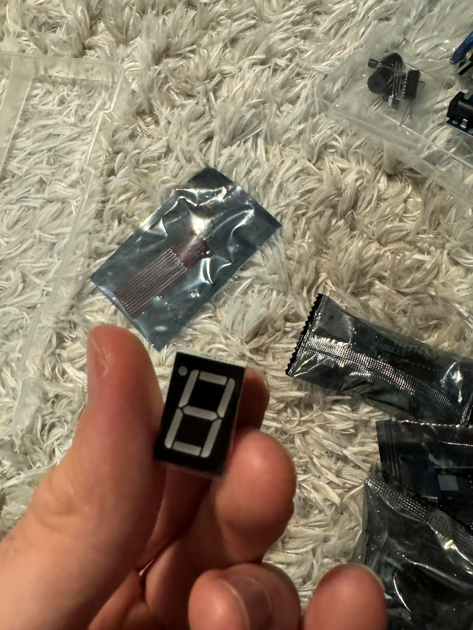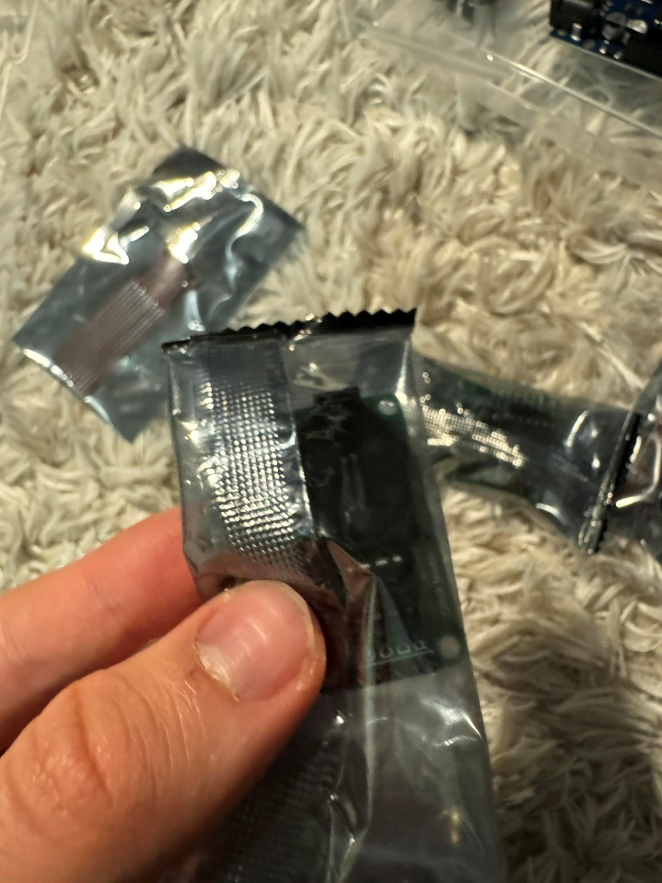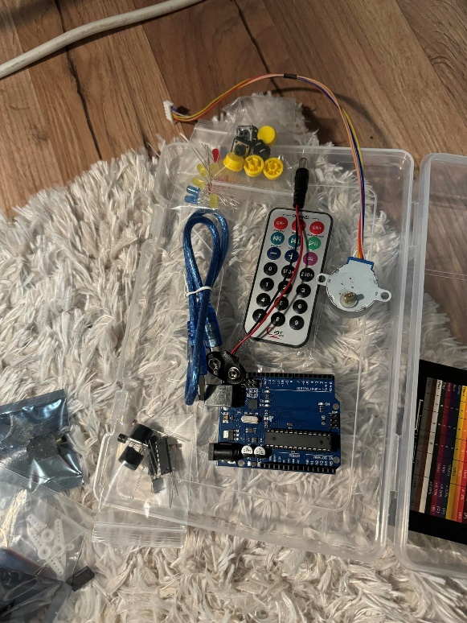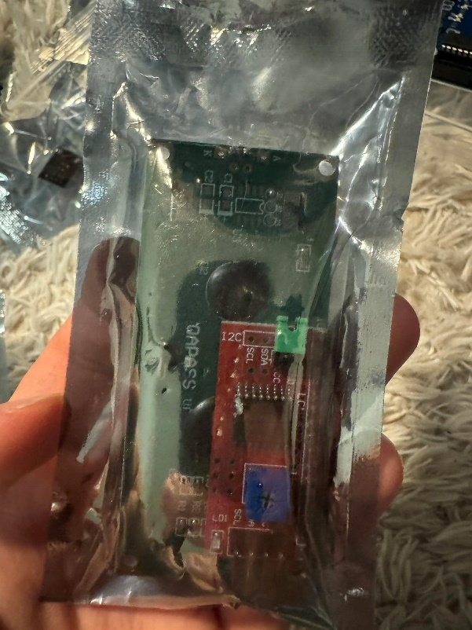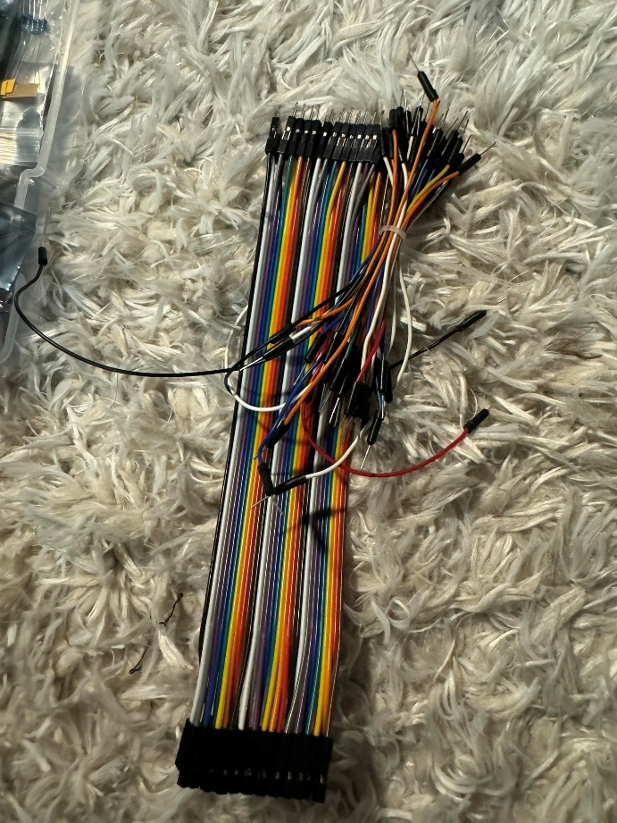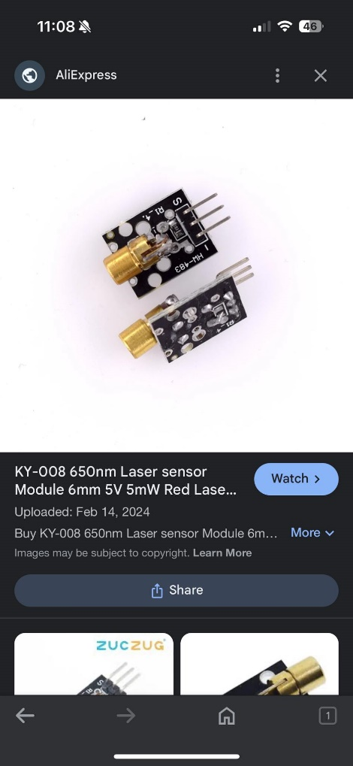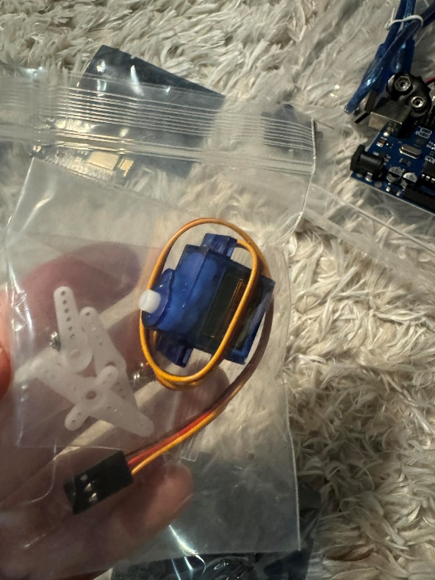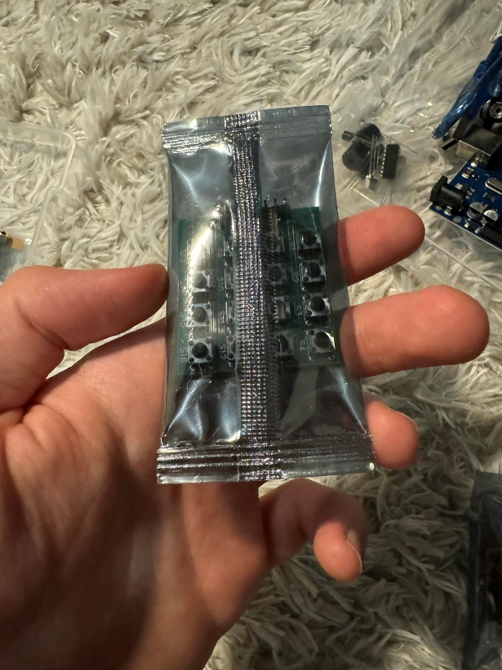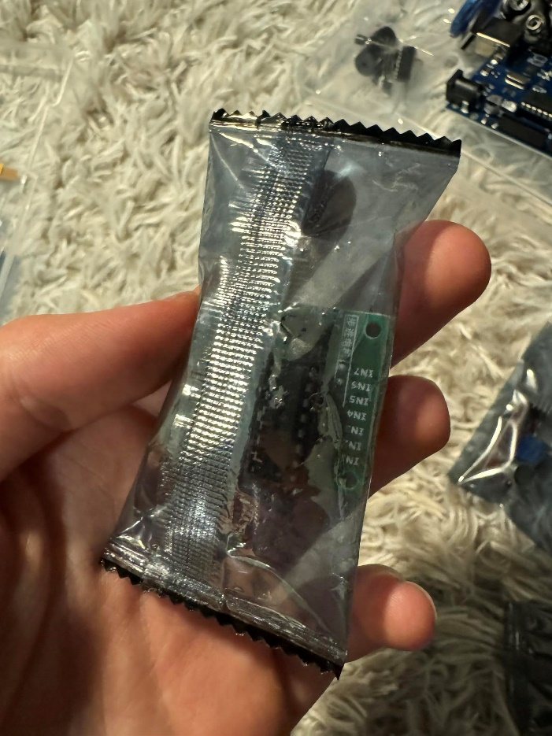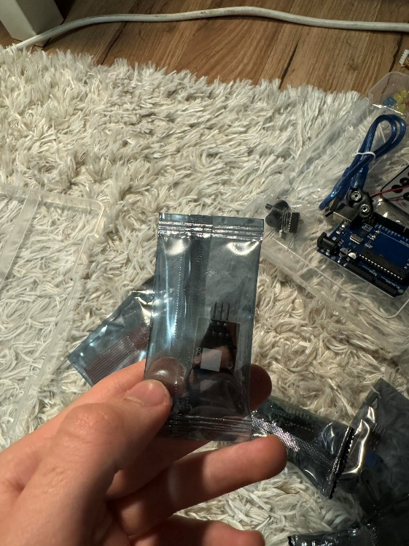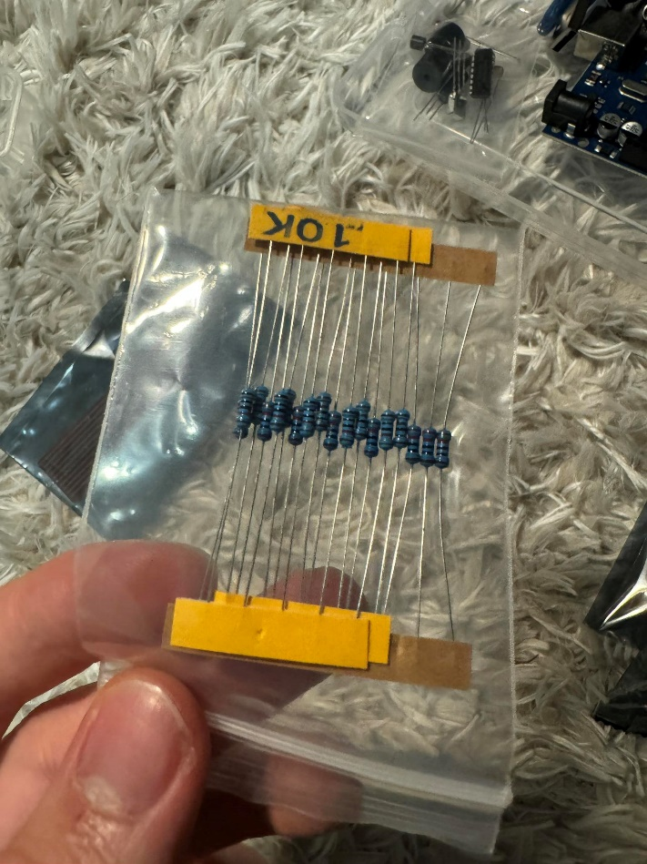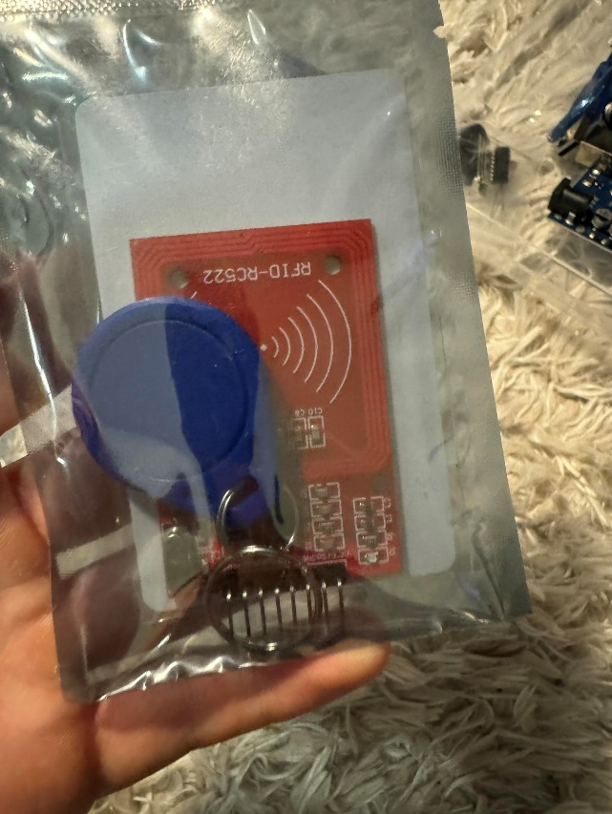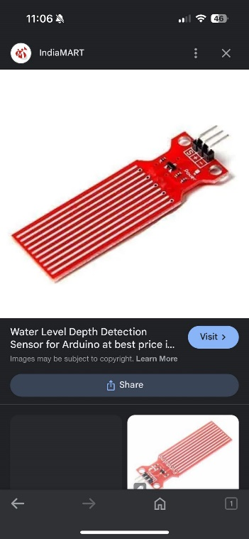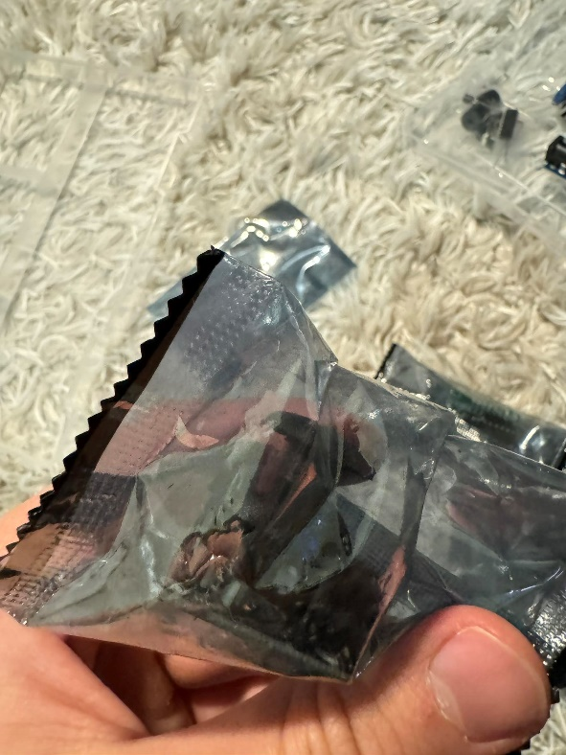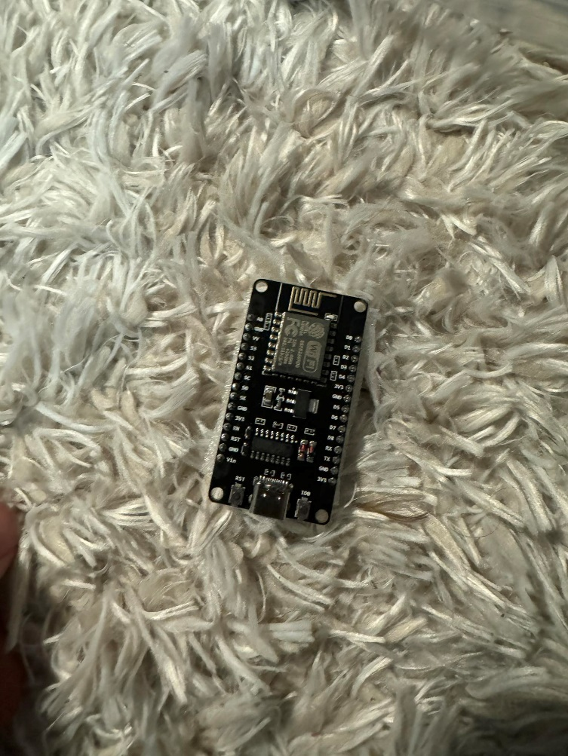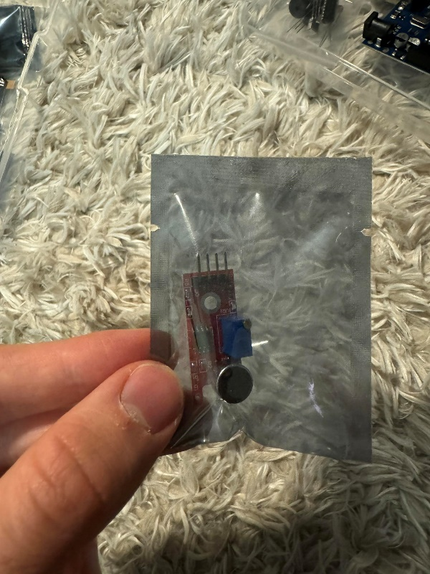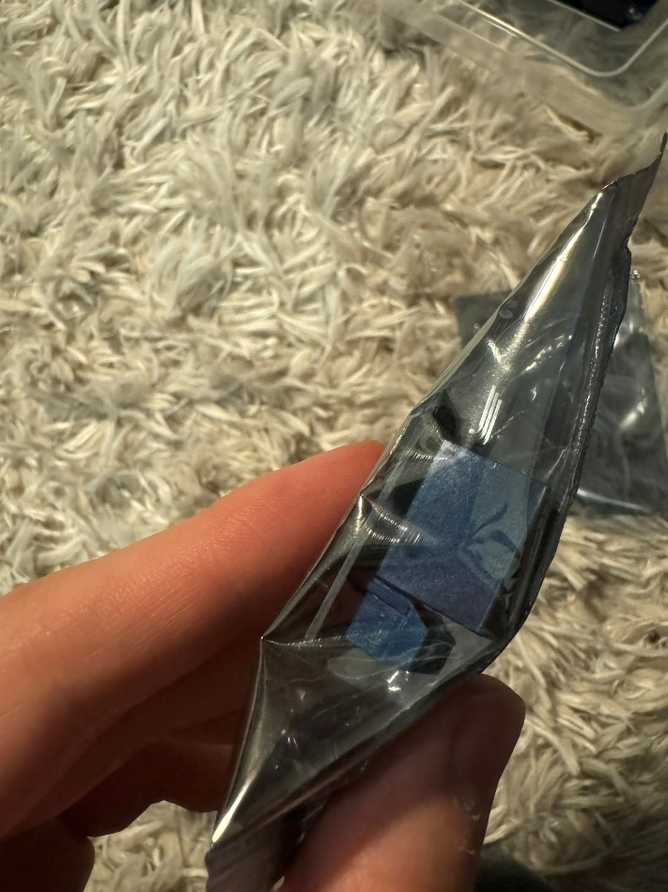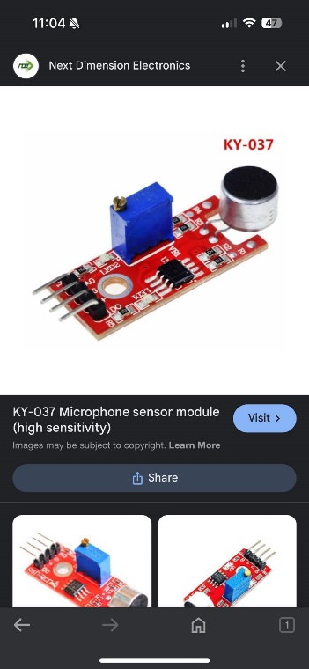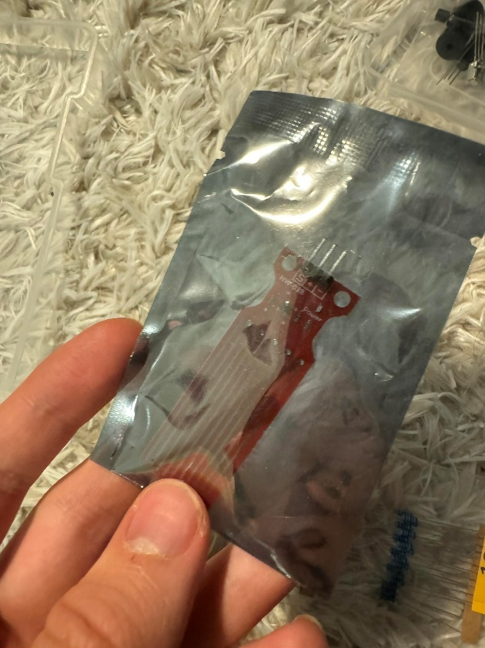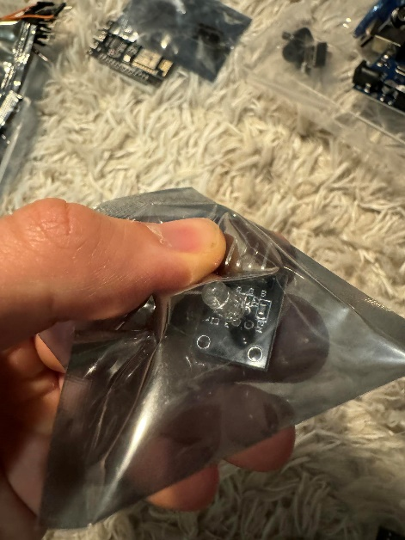

Pictures of researched items.

--

Used items – Prototype 1

Arduino Uno

HC-SR04 Ultrasonic Sensor

RGB LED Module

Servo Motor

Piezo Buzzer

Initial Setup:

Configured the ultrasonic sensor to measure distance and trigger RGB LED color changes based on proximity.

Integrated a servo motor to simulate physical movement as part of the interactive experience.

Issues Encountered:

Difficulty achieving smooth color transitions with the RGB LEDs.

Initial tests with the servo motor showed erratic movements, not aligning with distance measurements accurately.

Week 3: Reevaluation and Shift in Approach

Needed to add more interaction (team words)

Used items – Prototype 2 - Failed

MFRC522 RFID Reader

Arduino Uno

HC-SR04 Ultrasonic Sensor

RGB LED Module

Servo Motor

Piezo Buzzer

Breadboard

Week 4-5: Refinement and Final Integration

Code Optimization:

Introduced a damping mechanism in the code to smooth out the transitions between color states.

Adjusted servo motor controls to provide a more gradual and precise response.

Shift to Button Matrix:

Due to the lack of smoothness in sensor responses, shifted focus to a Joy-it SBC button matrix as an alternative control method.

Re-coded the setup to respond to button presses, changing colors and activating the servo motor.

Testing and Feedback:

Conducted internal tests which showed improved stability but still lacked the desired fluidity in transitions.

Received feedback regarding the abruptness of color changes and the need for more granular control.

Final Setup:

Established a system where different buttons trigger specific colors, blending into each other smoothly as different buttons are pressed in succession.

Final integration tests conducted to ensure all components interact seamlessly.

Challenges Resolved:

Fine-tuned the servo's responsiveness to ensure it moved in sync with the changing lights.

Documentation and Learning:

Sources and References:

Utilized online tutorials for basic sensor and RGB LED integration.

Consulted Arduino community forums for advanced troubleshooting with servo motors.

Adapted a publicly available HSL to RGB conversion function to fit the project's needs, with significant modifications for performance enhancement.

Development Insights:

Learned the importance of iterative testing and gradual component integration.

Gained skills in adapting and integrating various hardware components to work in unison for a cohesive interactive experience.

Conclusion and Future Directions:

The project, though challenging, resulted in a versatile interactive light installation that can be adapted or expanded in future developments.

Find cheaper and more suitable way to install the Final form.

Maybe

Plans to explore more energy-efficient sensors and perhaps integrate solar power to enhance sustainability for long-term outdoor use.  
  
KPI’s  
  
Realisation-U1.1:

"I made sure every part of our interactive project was up to scratch by testing everything rigorously. We used the best tools and guidelines out there, so nothing was left to chance."

Realisation-H1.1:

"I got to work on the software for our setup, making sure our sensors and actuators worked perfectly with the hardware we picked."

Advise-S1.1:

"After looking into similar systems, I came up with some solid advice on how we could tweak our software to make it even better and meet our unique needs."

Design-H1.1:

"I took on designing the core system that our project hinged on, ensuring it was tough enough to handle what we needed it to do."

Analysis-H1.2:

"I spent a lot of time getting to know exactly how our sensors and actuators behaved, making sure they worked well together and met our expectations."

Design-U1.1:

"I put our design through the wringer, following a clear and simple process to make sure our user interactions were on point."

Handling Hardware:

"I rolled up my sleeves and tested out our new hardware pieces, building a prototype that really put them through their paces."

TI-1.5 (Targeted Interaction):

"I made sure to keep everyone in the loop, making clear what each person’s role was and keeping our communications open and effective."

FOO-1.1 (Future-Oriented Organisation):

"I was always thinking about the bigger picture, making sure our project didn’t just succeed now but also did the right thing by people and the planet."

Code

That is my first code for the Ultrasonic sensor used for the original idea Interactive Pathway.

Video of the effect

Showing simple program with changing RGB light and buzzer sound.

